**BA24 Pastor Email**

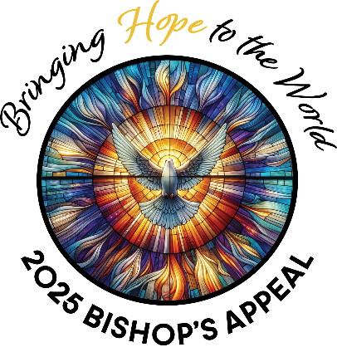

February 8, 2025

Dear <<First Name>>,

As I look around our Diocese, I see hope everywhere. Our parish plays an important role in *Bringing Hope to the World*, and our Diocese needs your help. Please consider how you can share your gifts with others, and join me in *Bringing Hope to the World* by making a gift to the  
Bishop’s Appeal.

You should have received a letter in the mail from Bishop Ricken asking for your support of the Appeal. Our parish is committed to Christ, and His work goes far beyond the walls of <<Parish Name>>. While the ministries supported by the Bishop’s Appeal are important every year, today they are even more essential to share Christ’s love with others.

**I’m asking for your help**. Our parish cares deeply about people in need, and we are a community of faith and generosity. I am confident we can surpass our goal this year because we know how important the ministries funded by the Bishop’s Appeal are to doing Christ’s work here in northeastern Wisconsin.

Please prayerfully consider making your gift today by sending your pledge in the blue envelope included with the letter from Bishop Ricken. You can also make your gift online by visiting [www.catholicfoundationgb.org/give](http://www.catholicfoundationgb.org/give).

We can make a difference in our community through our generosity!

God bless you, and please continue to pray for our parish family.

Gratefully,

<<Pastor/Pastoral Leader Name>>

Week 4 – February 22, 2025

Electronic communications are a particularly important means of staying in touch with parishioners. They reinforce your messages to those who are attending Mass and other parish activities in person.

The following email is offered as a guide for crafting your own parish emails and newsletters. Please note that when modifying, the giving link must remain the same.

Please send this email on or around Saturday, February 22. We recommend sending this as a stand-alone email and not including it in the regular parish email.

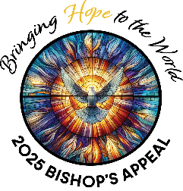

Dear <<First Name>>,

Lent is almost here, giving us pause and allowing us time for deeper reflection. As I think about the blessings in my life, I am overwhelmingly grateful to be with you on this path to our Lord.

Because of your prayers and support, our parish’s Bishop’s Appeal is off to a strong start.  I am not surprised, as our parish has always responded generously when asked.

The Bishop’s Appeal supports ministries and programs that serve those in need through Catholic Charities. It provides opportunities to grow our leaders in Catholic education and faith formation. You make this and more possible through your gift. Thank you!

These extraordinary times require an extraordinary response of faith and generosity. If you haven’t yet had the opportunity to give, please prayerfully consider joining me by supporting the 2025 Bishop’s Appeal.

It is fast and simple to share your blessings with our brothers and sisters in one of two ways:

1. Make your pledge online at [www.catholicfoundationgb.org/give](http://www.catholicfoundationgb.org/give)
2. Send back the blue envelope and gift card that were included with the letter from Bishop Ricken with a check or credit card pledge.

Every gift is important and has the power to transform thousands of lives throughout northeastern Wisconsin. Blessings are multiplied when all of us work together.

May God bless you and your family this Lent. Please continue to pray for the continued health of our community. Together, we are *Bringing Hope to the World!*

Gratefully,

<<PASTOR/PASTORAL LEADER NAME>>

P.S. Please make your gift today at [www.catholicfoundationgb.org/give](http://www.catholicfoundationgb.org/give)

Week 6 – March 8, 2025

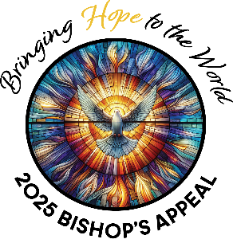

Dear <<First Name>>,

The 2025 Bishop’s Appeal is off to a tremendous start!

If you have already made your gift, thank you! Will you please say a prayer right now for our continued success? So far, xxx families have made their gift, and we have raised a total of $x,xxx

As we continue our Lenten journey and prepare our hearts for Christ’s resurrection this Easter, I think of how the Lord is present in everyday miracles. I think of our <<Faith Formation Program Name>> students and how much they’ve grown in their faith. The Lord is truly walking with them and their faith formation leaders. Because of your gift to the Bishop’s Appeal, you make training opportunities for their leaders possible. Thank you!

If you have not yet made your gift, it is simple. You can give in one of two ways:

1. Give online at [www.catholicfoundationgb.org/give](http://www.catholicfoundationgb.org/give) or
2. Send back your pledge in the blue envelope that was included with Bishop Ricken’s letter you received at home.

God bless you for your generosity, and please continue to pray for all the great works accomplished through the Bishop’s Appeal. Together, we are *Bringing Hope to the World!*

Gratefully,

(PASTOR/PASTORAL LEADER NAME)